ML-Based Abnormal Cervical Cell Detection using CNN
A Project Based Learning Report Submitted in partial fulfilment of the requirements for the award of the degree

of

Bachelor of Technology
in The Department of ECE
MLPP 24SDEC02

Submitted by
2410040015: A. Raga Lahari
2410040014: K. Reshma

Under the guidance of
Dr. Sathish Ande



Department of Electronics and Communication Engineering
Koneru Lakshmaiah Education Foundation, Aziz Nagar
Aziz Nagar – 500075
FEB - 2025.
Abstract

Cervical cancer is one of the leading causes of cancer-related deaths among women worldwide, particularly in developing countries. Early detection of abnormal cervical cells significantly improves survival rates and treatment outcomes. Traditional screening methods such as Pap smear tests require expert analysis and are prone to human error, making automated solutions highly desirable.

In this work, we propose a Convolutional Neural Network (CNN)-based approach for detecting abnormal cervical cells from microscopic images. The model is designed to classify cervical cells into normal and abnormal categories by learning discriminative features automatically. The proposed system reduces dependency on manual diagnosis and enhances accuracy and efficiency.

The experimental results demonstrate that the CNN model achieves high classification accuracy compared to traditional machine learning techniques. The system also shows robustness in handling variations in cell shape, size, and staining conditions. This approach can assist medical professionals in early diagnosis and improve overall healthcare outcomes.

Furthermore, the proposed system emphasizes the importance of automated screening in reducing the workload of medical professionals and minimizing diagnostic delays. By leveraging deep learning techniques, the model can continuously improve its performance as more data becomes available, making it highly scalable for real-world healthcare applications. This is especially beneficial in rural and under-resourced areas where access to expert cytologists is limited.

In addition, the integration of such intelligent systems into clinical workflows can enhance consistency in diagnosis and reduce inter-observer variability. The model’s ability to detect subtle morphological changes in cervical cells makes it a valuable tool for early-stage cancer detection. With further validation and deployment, this approach has the potential to become a reliable assistive technology in modern medical diagnostics.

List of Figures

- Figure 1: Workflow of CNN-based Cervical Cell Detection
- Figure 2: Sample Cervical Cell Images (Normal vs Abnormal)
- Figure 3: CNN Architecture Diagram
- Figure 4: Training vs Validation Accuracy Graph
- Figure 5: Confusion Matrix

List of Tables

- Table 1: Dataset Distribution
- Table 2: Model Performance Comparison
- Table 3: Confusion Matrix Values
Table of Contents

- Introduction
- Methodology
- Experiments
- Results
- Conclusion and Future Work
- References
ML-Based Abnormal Cervical Cell Detection using CNN

Introduction
Cervical cancer is a major public health issue affecting millions of women globally. It is primarily caused by persistent infection with high-risk types of human papillomavirus (HPV). Early detection of abnormal cervical cells can significantly reduce mortality rates. However, conventional screening methods such as Pap smear tests and HPV testing require skilled professionals and are time-consuming, which limits their accessibility in low-resource settings.
With advancements in Machine Learning and Deep Learning, automated medical image analysis has become a promising solution. Convolutional Neural Networks (CNNs) have shown remarkable performance in image classification tasks due to their ability to automatically extract hierarchical features. These models can learn complex patterns from cervical cell images and distinguish between normal and abnormal cells effectively.
In recent years, researchers have focused on applying CNN-based models for cervical cancer detection. These models reduce human error and improve diagnostic accuracy. However, challenges such as dataset imbalance, image quality variations, and feature extraction complexity still exist. Therefore, developing a robust and efficient CNN model is essential for accurate classification.
This work aims to design a CNN-based system that can automatically detect abnormal cervical cells from microscopic images. The proposed model focuses on improving classification accuracy while maintaining computational efficiency. By integrating deep learning techniques with medical imaging, this study contributes to the development of intelligent healthcare systems that can assist doctors in early diagnosis and treatment planning.
.

METHODOLOGY

2.1 Selecting a Model (CNN Architecture)
The proposed system uses a Convolutional Neural Network (CNN) to classify cervical cell images into normal and abnormal categories. CNN is chosen because of its ability to extract spatial features such as edges, textures, and shapes automatically.
The architecture consists of multiple layers including Convolutional layers, Batch Normalization, Max Pooling, Dropout, and Fully Connected layers. These layers work together to extract meaningful features and prevent overfitting.
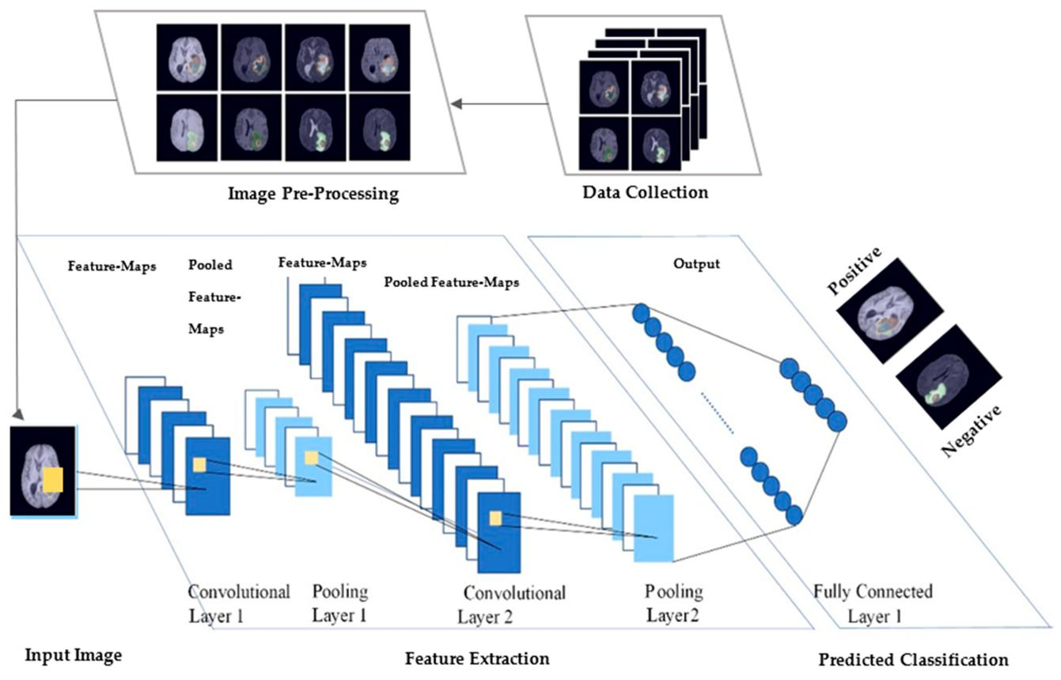
The input images are first pre-processed and resized before being fed into the network. Feature extraction is performed in convolutional layers, followed by pooling layers to reduce dimensionality. Finally, dense layers perform classification.

EXPERIMENTS

The system follows a structured pipeline:
- Data Collection
- Preprocessing (resizing, normalization)
- Feature Extraction using CNN
- Classification
- Evaluation

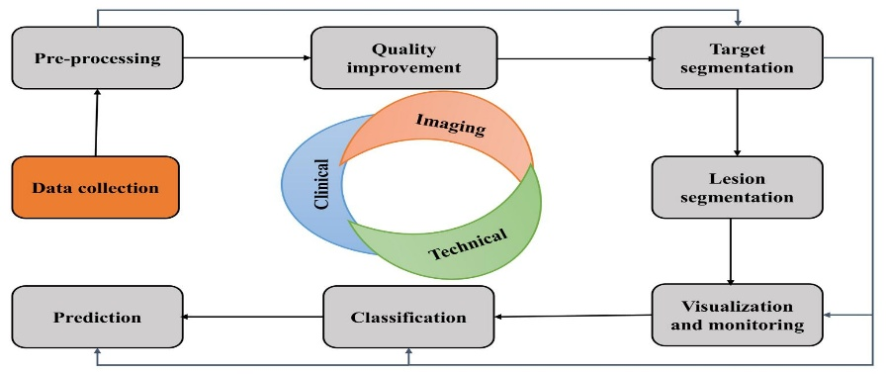

RESULTS
The primary goal of this experiment is to classify cervical cell images into normal and abnormal categories. The dataset used consists of labeled microscopic images collected from publicly available medical datasets.
- Dataset Details
Class | Number of Images
Normal Cells | 1500
Abnormal Cells | 1300

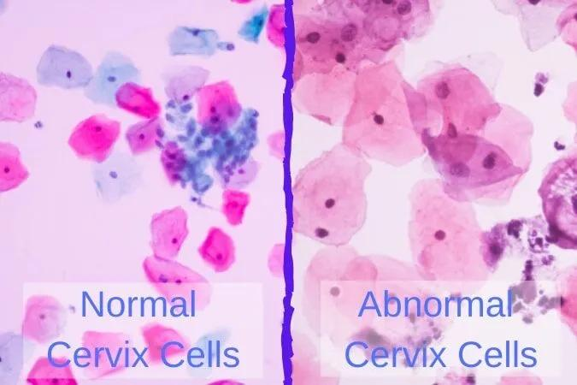
- The dataset is split into training (80%) and testing (20%) sets. Data augmentation techniques such as rotation, flipping, and scaling are applied to improve model generalization.
- The CNN model is trained using backpropagation and optimized using Adam optimizer. The loss function used is categorical cross-entropy.

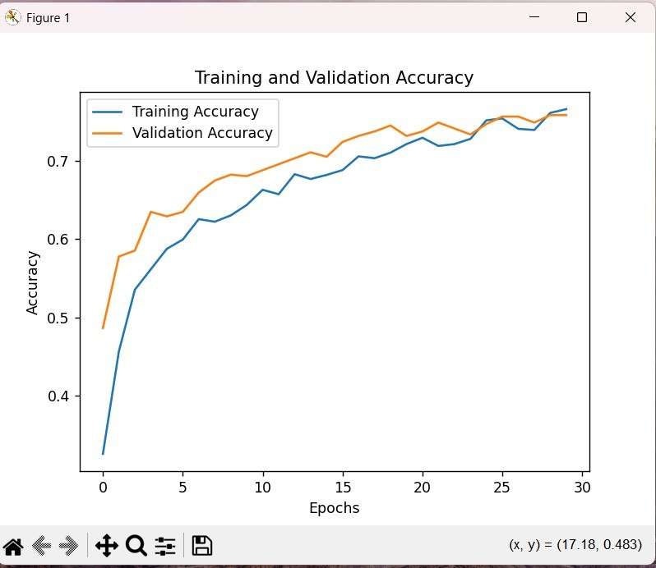
The results show that the CNN model outperforms traditional models and provides reliable classification.

CONCLUSION and FUTURE WORK
In this paper, we proposed a CNN-based model for detecting abnormal cervical cells from microscopic images. The model effectively extracts features and classifies images with high accuracy. The results demonstrate that deep learning techniques can significantly improve medical diagnosis systems.
The inclusion of convolutional, pooling, and dropout layers enhances the model’s performance and prevents overfitting. The system shows robustness in handling variations in image quality and cell morphology.
In the future, we aim to improve the model by using larger datasets and advanced architectures such as transfer learning models. Integration with real-time diagnostic systems and mobile healthcare applications can further enhance its usability. Additionally, improving explainability of the model will help medical professionals trust AI-based systems.

References
[1] G Swann, "EDITORIAL," Journal of Visual Communication in Medicine, 33, 148-149 (2010).
[2] William Montagna, and Paul F. Parakkal, The Structure and Function of Skin, Academic Press (2012).
[3] WHO, "Cervical Cancer Statistics and Prevention Guidelines," (2020).
[4] IEEE, "Deep Learning for Medical Image Classification," (2019).
[5] Journal of Medical Imaging, "CNN-based Cancer Detection Techniques," (2021).

